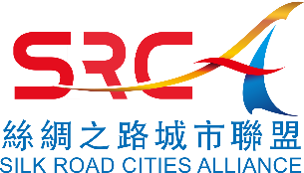 | Silk Road Cities Alliance

Employment Application/就业申请

Applicant Information/申请人信息
Full Name/全名: |  |  |  | Date:
 | Last | First | M.I.

Address/地址:
 | Street Address | Apartment/Unit #

 | City | State | ZIP Code

Phone/电话: |  | Email

Are you a citizen of the People’s Republic of China? | YES | NO | Are you a member of Silk Road Young Leaders Club? | YES | NO

Have you ever worked for SRCA? | YES | NO

Have you ever been convicted of a felony? | YES | NO

If yes, explain:

Education/教育
Graduation Institute :

From: |  | To:

Previous Employment if any/以前的就业 (如果有)
Company: |  | Phone:
Address: |  | Supervisor:

Job Title:

Responsibilities:

From: |  | To: |  | Reason for Leaving:

May we contact your previous supervisor for a reference? | YES | NO

Disclaimer and Signature
I certify that my answers are true and complete to the best of my knowledge. 我保证, 提供的信息是真实和完整的。
If this application leads to employment, I understand that false or misleading information in my application or interview may result in the termination of my employment. 我同意,如在申请或面试中提供了虚假或误导的信息，有可能导致雇佣被终止。
Signature: |  | Date:

